# Slicing Time Series

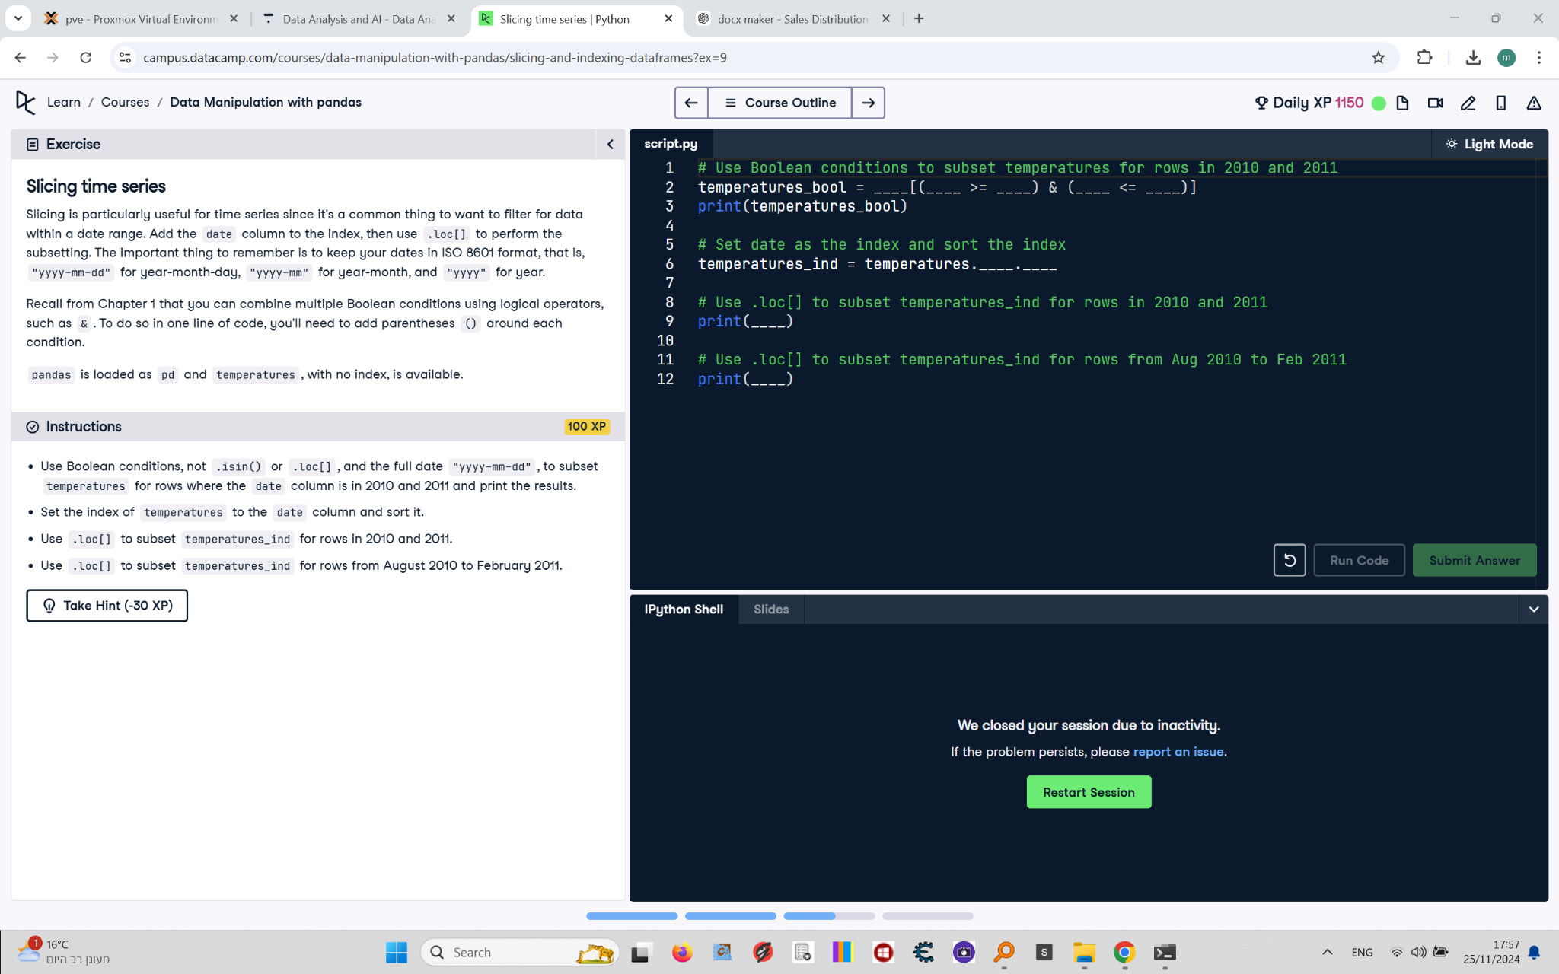

Slicing is particularly useful for time series since it's a common thing to want to filter for data within a date range. Add the date column to the index, then use .loc[] to perform the subsetting. The important thing to remember is to keep your dates in ISO 8601 format, that is, 'yyyy-mm-dd' for year-month-day, 'yyyy-mm' for year-month, and 'yyyy' for year.  
  
Recall from Chapter 1 that you can combine multiple Boolean conditions using logical operators, such as &. To do so in one line of code, you'll need to add parentheses () around each condition.  
  
pandas is loaded as pd and temperatures, with no index, is available.

## Final Answer

# Use Boolean conditions to subset temperatures for rows in 2010 and 2011  
temperatures_bool = temperatures[(temperatures["date"] >= "2010-01-01") & (temperatures["date"] <= "2011-12-31")]  
print(temperatures_bool)  
  
# Set date as the index and sort the index  
temperatures_ind = temperatures.set_index("date").sort_index()  
  
# Use .loc[] to subset temperatures_ind for rows in 2010 and 2011  
print(temperatures_ind.loc["2010":"2011"])  
  
# Use .loc[] to subset temperatures_ind for rows from Aug 2010 to Feb 2011  
print(temperatures_ind.loc["2010-08":"2011-02"])